COURSE CODE: BIT 4107
COURSE TITLE: MOBILE APPLICATION DEVELOPMENT
STUDENT NAME: JOYCE KANG’ARI
REGISTRATION NUMBER: BIT/2024/57127

WEEK1
Installation of development tools
I installed the required development tools as the following diagrams show:
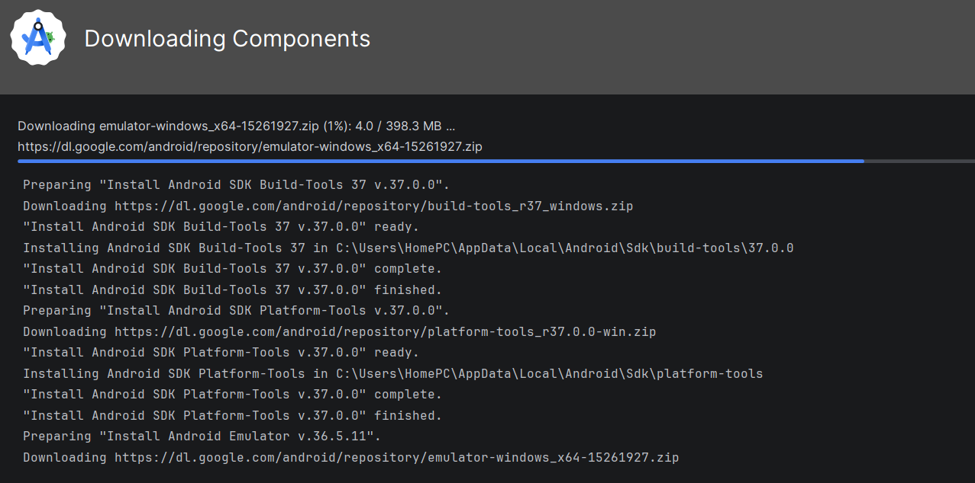
This diagram above shows the installation process of the android studio and all its tools.
After installation I went ahead to test if everything was working properly and if I could create a project with it as shown below.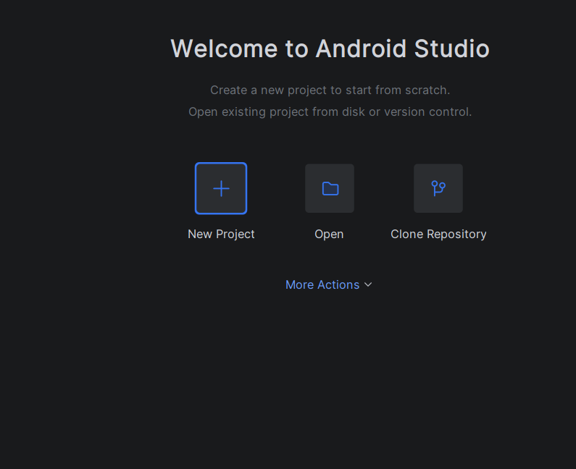
Then installed and enabled the emulator so that I could see the display after inserting a code as below.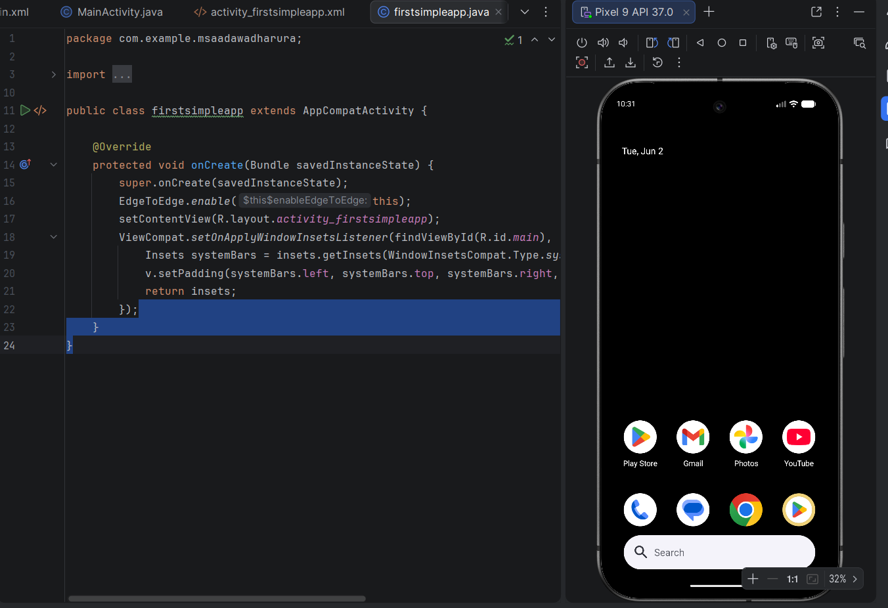
After that I headed on creating an app using java that could change title, background color and font as below.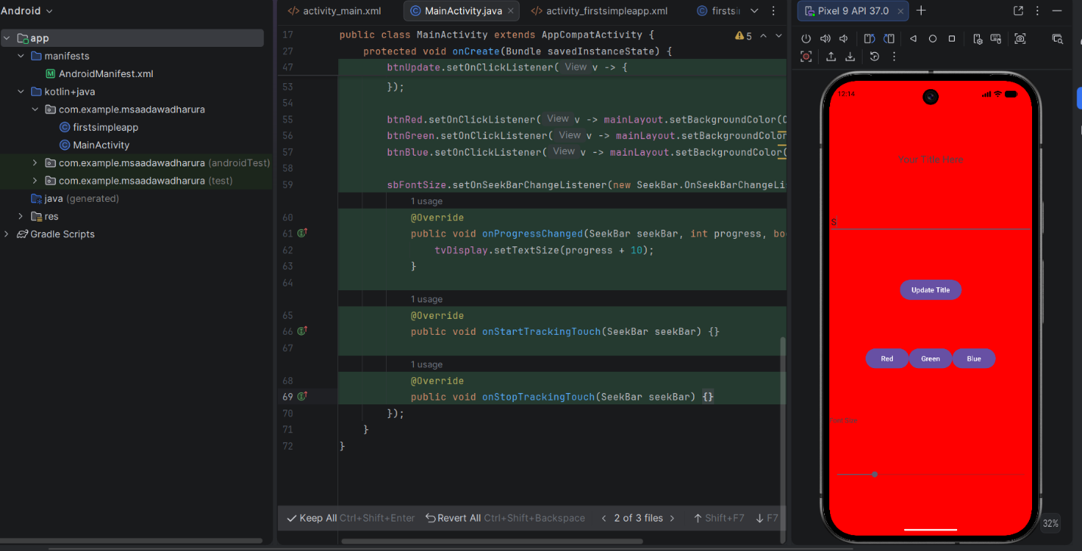
CHALLENGES
1.Code not being able to run at first.
2.Difficulty in Starting the emulator.
WEEK 2
Created a ministudentapp as the diagram below shows.
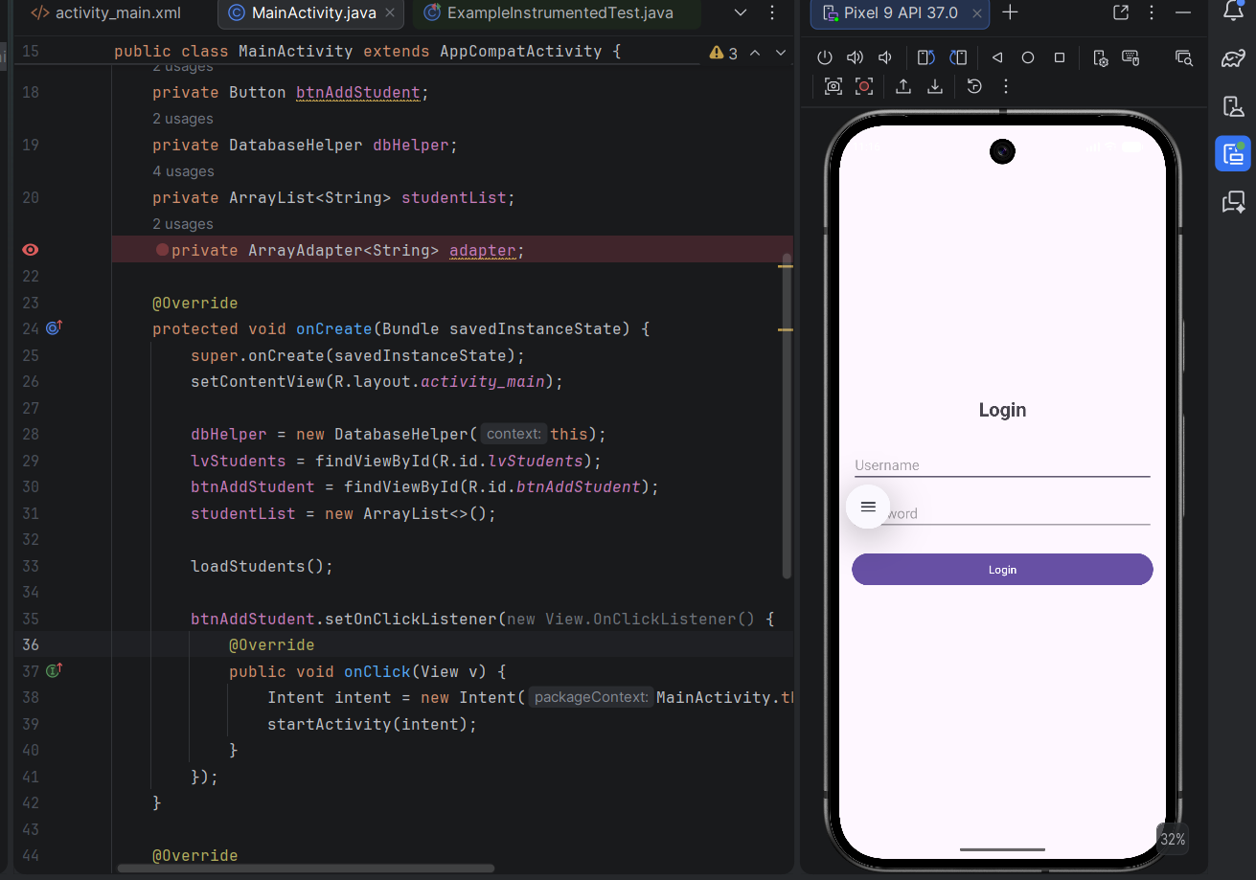
Challenges
- Emulator not running in time
- Errors in code causing emulator not to run.
- Emulator not responding instantly when numbers and letters are pressed.

WEEK 3
Here I created the Figma screens and navigation working area. I also tried to make the screens responsive and functional . The diagrams below explain everything.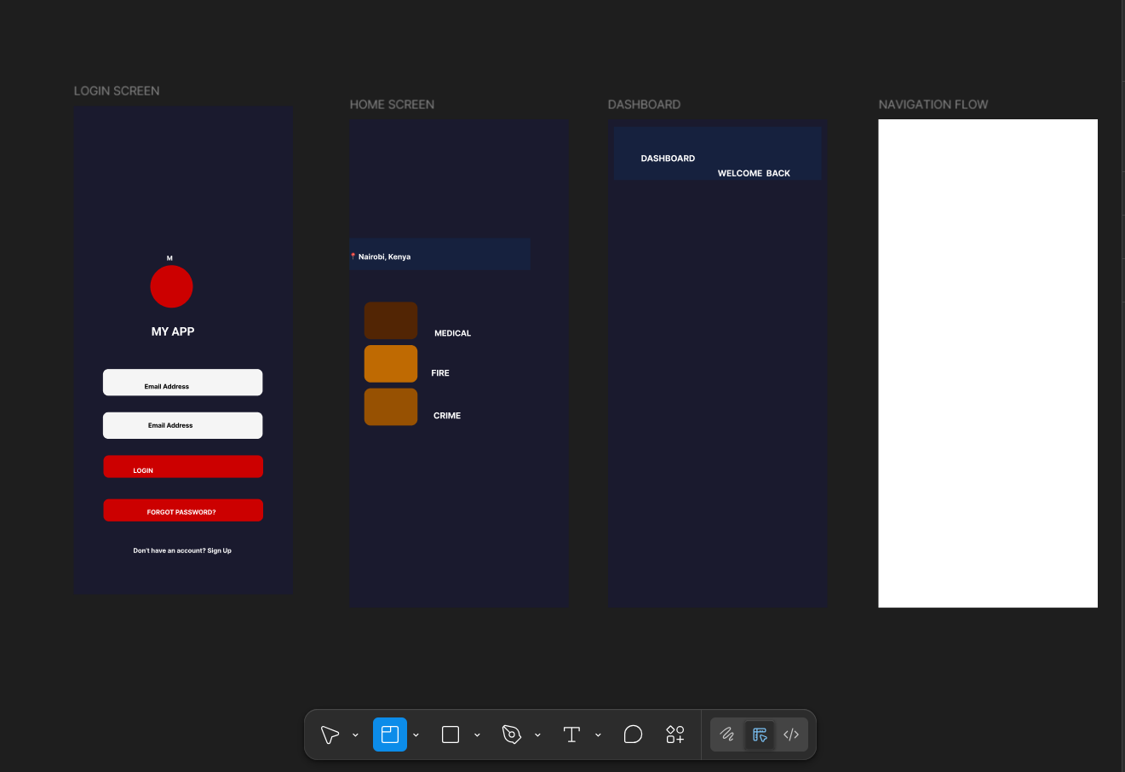
This screenshot shows the screens I designed in figma. The log in screen, Home screen , dashboard and the navigation flow.
I designed the icons and placed the icons in the screen.
I then tried to make the screens functional by adding functionality.
The diagram below shows the process.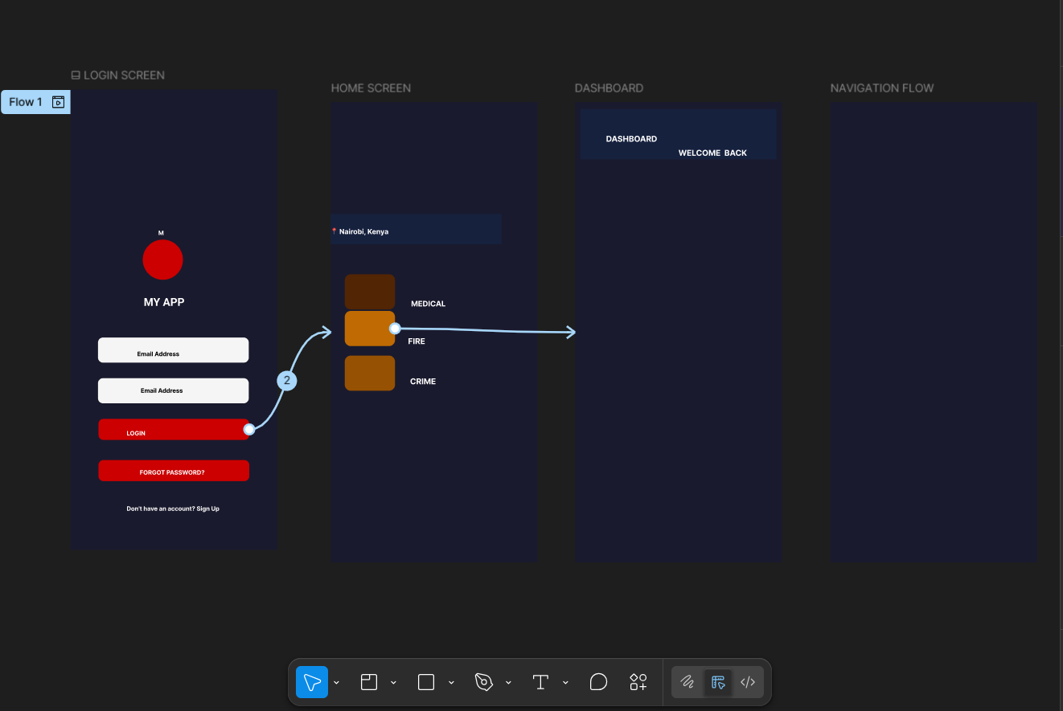
CHALLENGES
Difficulty drawing icons.
Difficulty in creating thumbnails.
Still trying to figure out.
WEEK 4
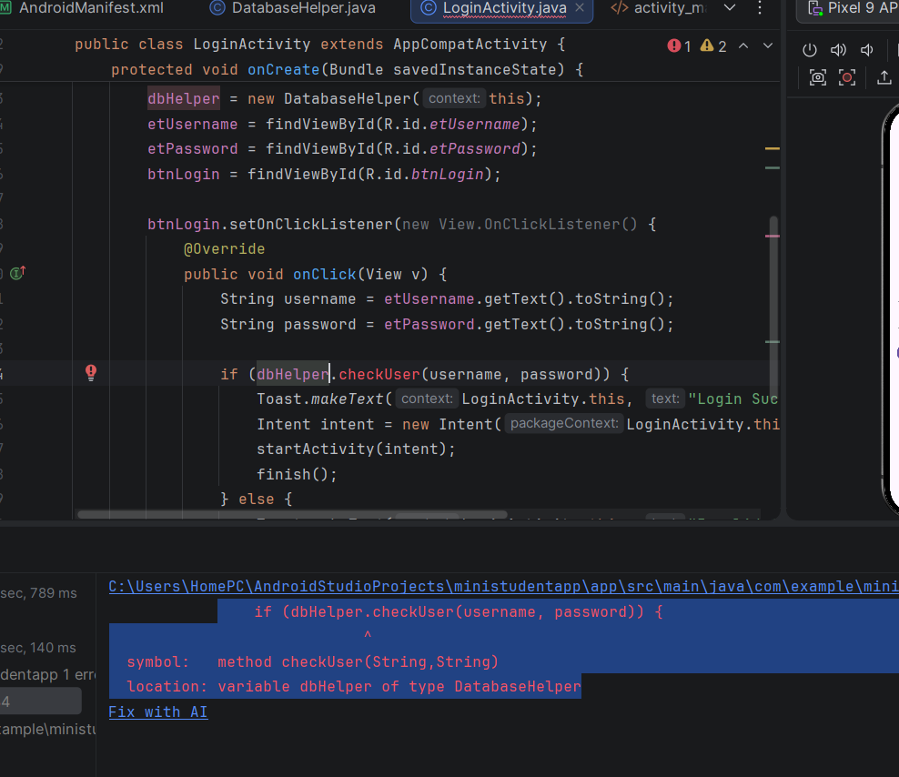
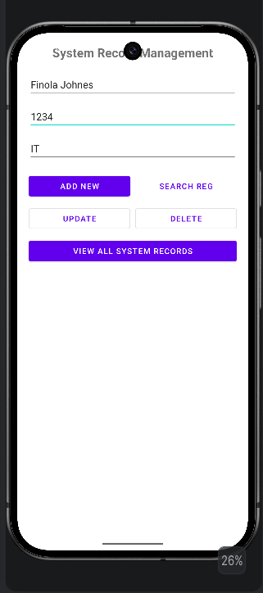
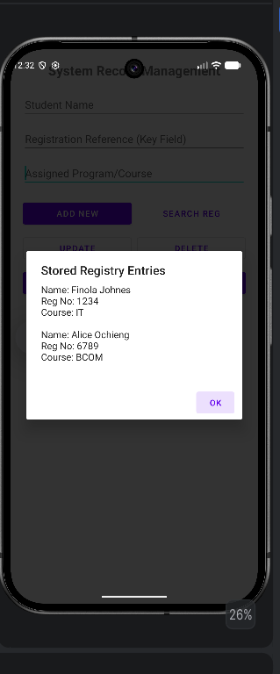
Student Registration System , A mobile application featuring user authentication and full CRUD (Create, Read, Update, Delete) capability utilizing an embedded local SQLite database.
Challenges
- Too much errors and being unable to locate them easily.
- Code not running.
- Emulator crashing every now and then
- Buttons not functioning properly.
WEEK 5
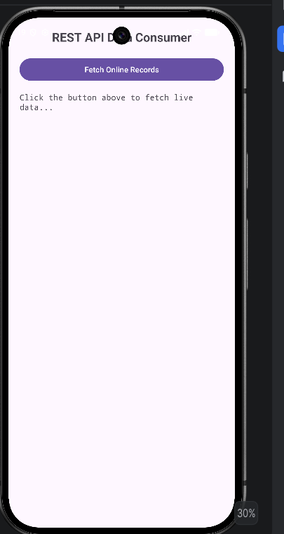
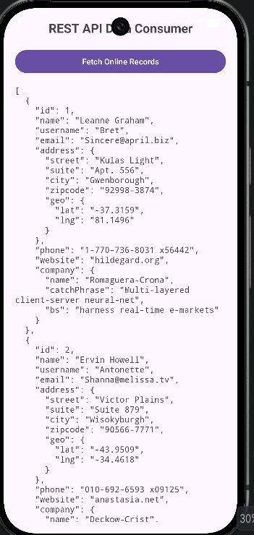
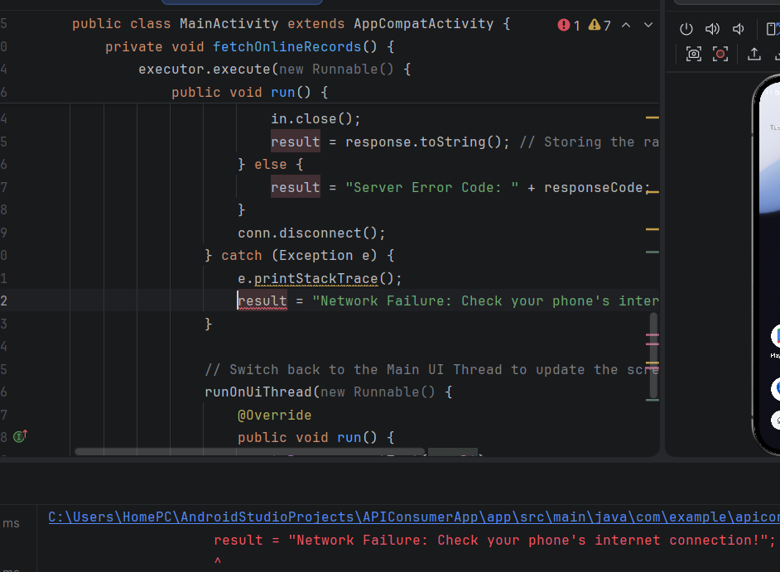
The application connects to a remote web server, dispatches an HTTP GET request, handles network exceptions, and renders dynamic online records on the user interface.
Challenges
1.Knowing how API’S operate in mobile apps
2. Failure almost at every code line.
3. Complex requests.

